**EX.No: 4**

**Date :**

**DATA SEGMENTATION BY COBWEB – HIERARCHIAL CLUSTERING**

**ALGORITHM USING WEKA TOOL**

.

**DESCRIPTION:**

Consider a dataset netscan.csv where it contains the attributes of Newsgroups, posts, posters, PPRatio, Returnees, Replies, Repliers, UnRMsgs, Avg.LineCT, Xports, XPTgs. Each attribute will have different types of the meanings.

**HIERARCHIIAL CLUSTERING:**

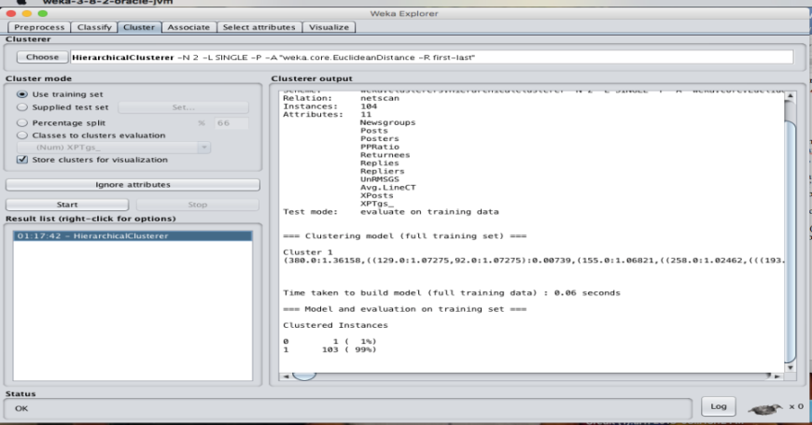

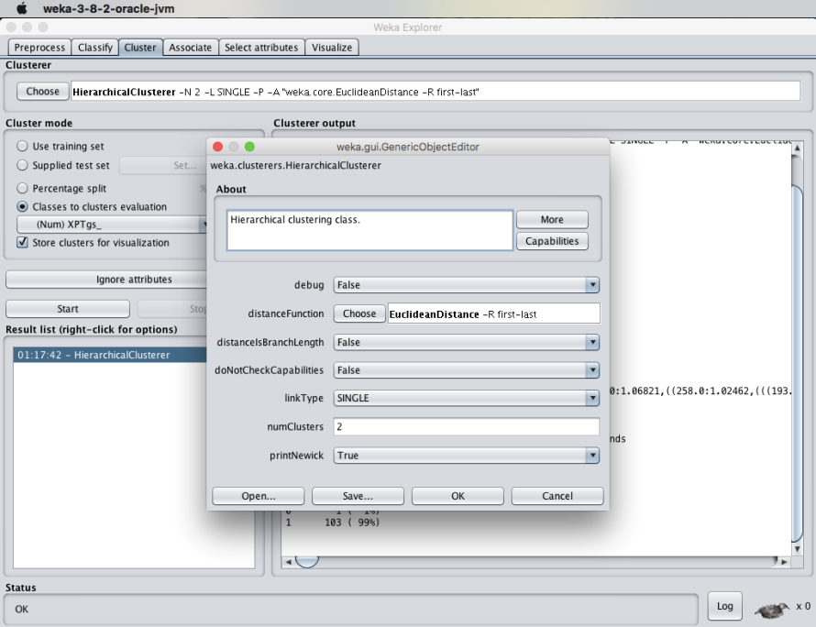

**RESULT :**  
 Thus, the data analysis of cobweb hierarchial clustering algorithm using weka tools has been analyzed and observed successfully.

**EX.No: 5**

**Date :**

**FREQUENT PATTERN MINING USING ASSOCIATION RULE**

**THROUGH**

**WEKA AND R TOOLS**

**DESCRIPTION :**

Consider a dataset of 2015.csv file of which it contains the attributes are Reference Number, Grid ref: Easting, Grid Ref: Northing, Number of vehicles, Accident date, Time(24 hr), 1st Road class, Road Surface, Lighting conditions, Weather conditions, casuality class, Sex of casuality, Age of casuality, Type of casuality for the performance of the dataset by applying the Apriori algorithm in weka and as well using R- tool.

* **USING WEKA TOOL :**

**STEPS INVOLVED :**

* Choose a set of attributes for clustering and for giving a motivation.
* Choose the dataset and import the dataset into Weka tool.
* Discretize the attributes from numeric to nominal to perform the algorithm.
* Cluster the dataset and choose simple Apriori algorithm.
* Set the Upper bound min_sup and lower bound min_sup values.

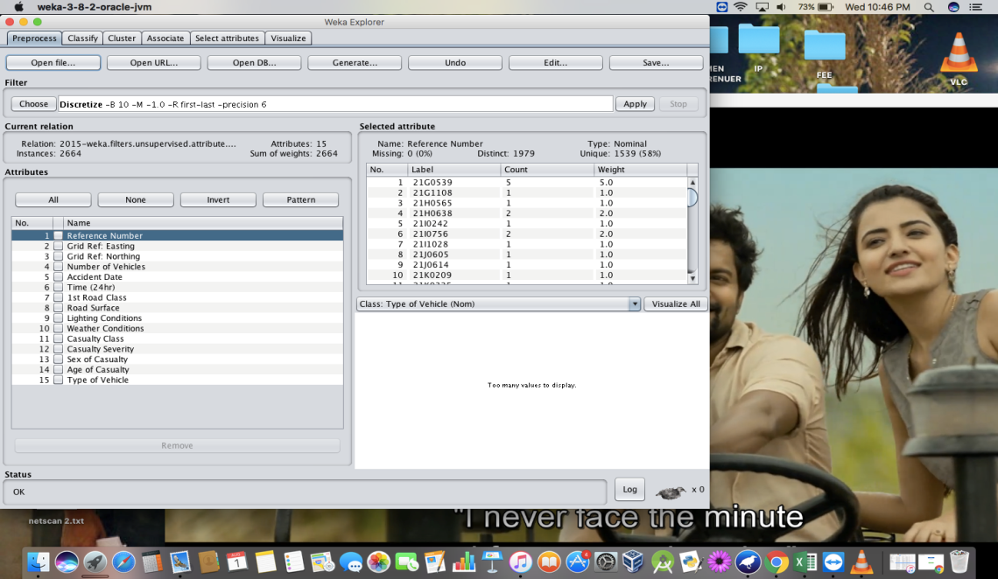

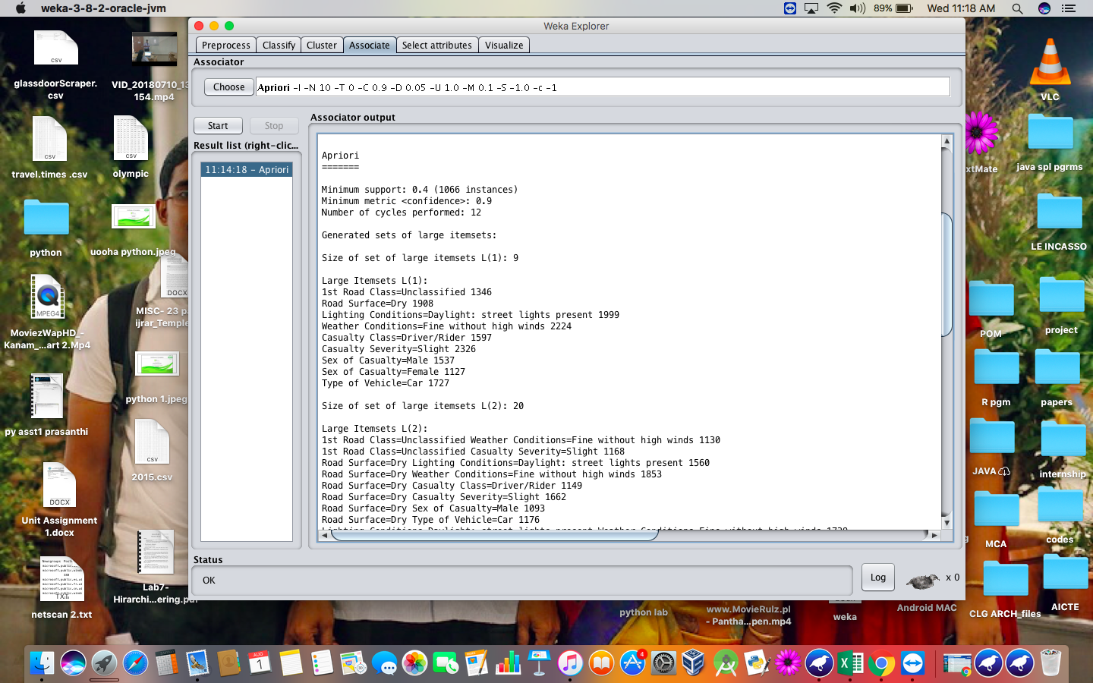

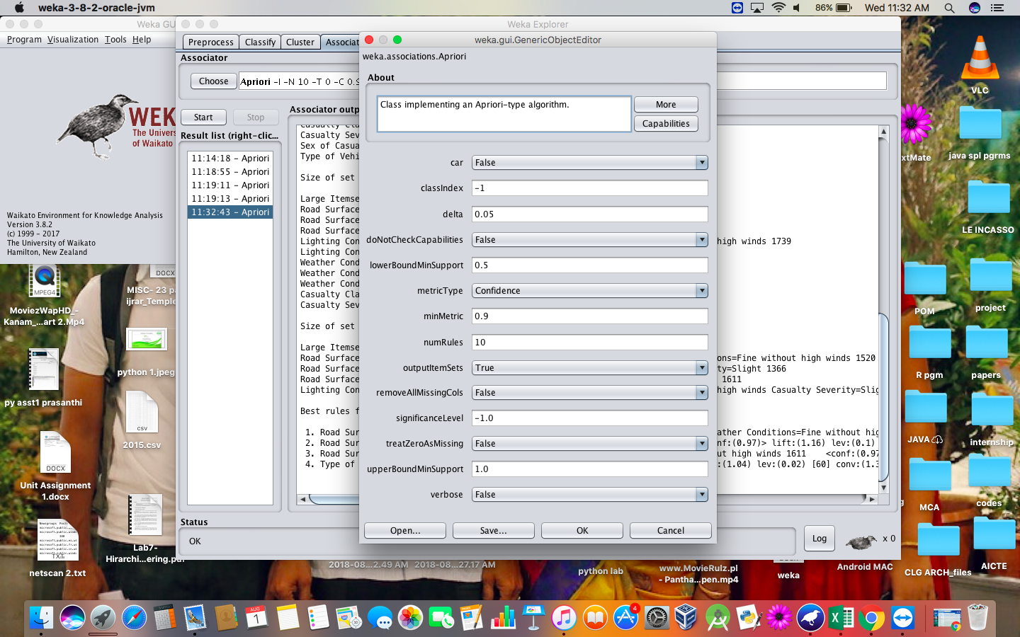

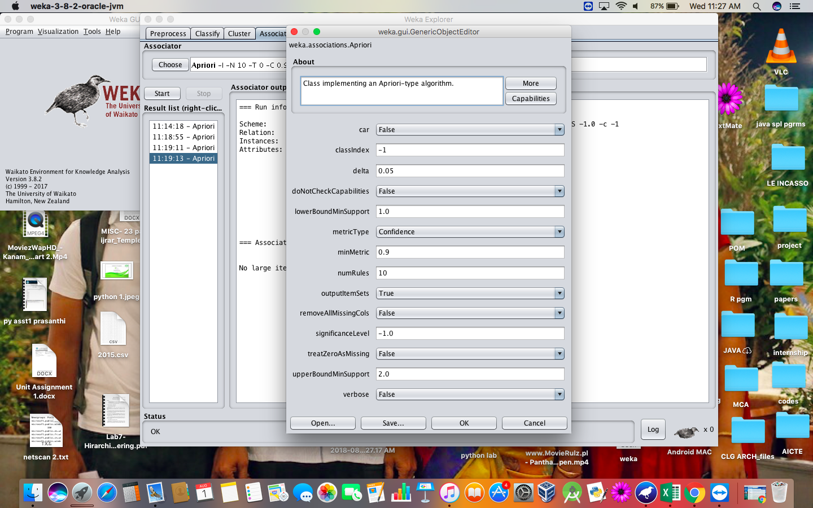

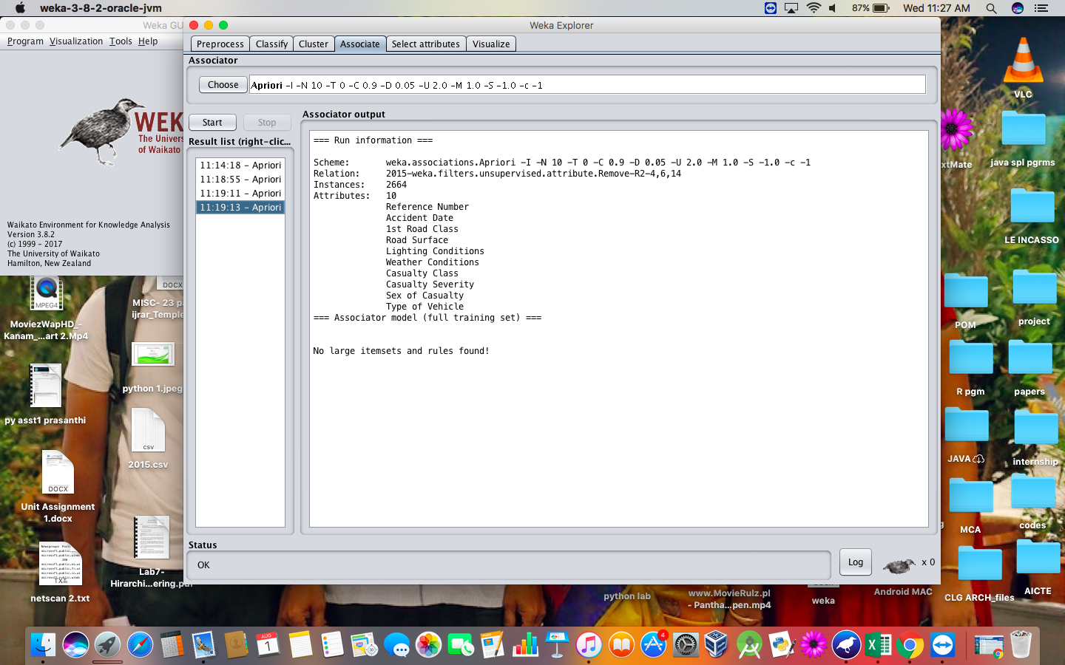

**RESULT :**

Thus, the Apriori algorithm analyzing using both the weka tool and R- tool has been successfully completed. In case of weka tool, the change in upper bound and lower bound values lead to the increase and decrease of number of itemsets and rules . In case of R-tool, there is an increase in absolute minimum support count value.

**EX.No: 6**

**Date :**

**FREQUENT PATTERN MINING USING FP GROWTH**

**THROUGH WEKA TOOL**

**DESCRIPTION :**

Consider a dataset of 2015.csv file of which it contains the attributes are Reference Number, Grid ref: Easting, Grid Ref: Northing, Number of vehicles, Accident date, Time(24 hr), 1st Road class, Road Surface, Lighting conditions, Weather conditions, casuality class, Sex of casuality, Age of casuality, Type of casuality for the performance of the dataset by applying the FP algorithm in weka tool.

* **USING WEKA TOOL :**

**STEPS INVOLVED :**

* Choose a set of attributes for clustering and for giving a motivation.
* Choose the dataset and import the dataset into Weka tool.
* Discretize the attributes from all data types to nominal to perform the algorithm.
* Associate the attributes with the FP growth algorithm.
* Set the Upper bound min_sup and lower bound min_sup values.

**OBSERVATIONS :**

1. When the association rules are of values:
2. Upper bound min_sup = 1.0
3. Lower bound min_sup = 0.1
4. Metric type = confidence.

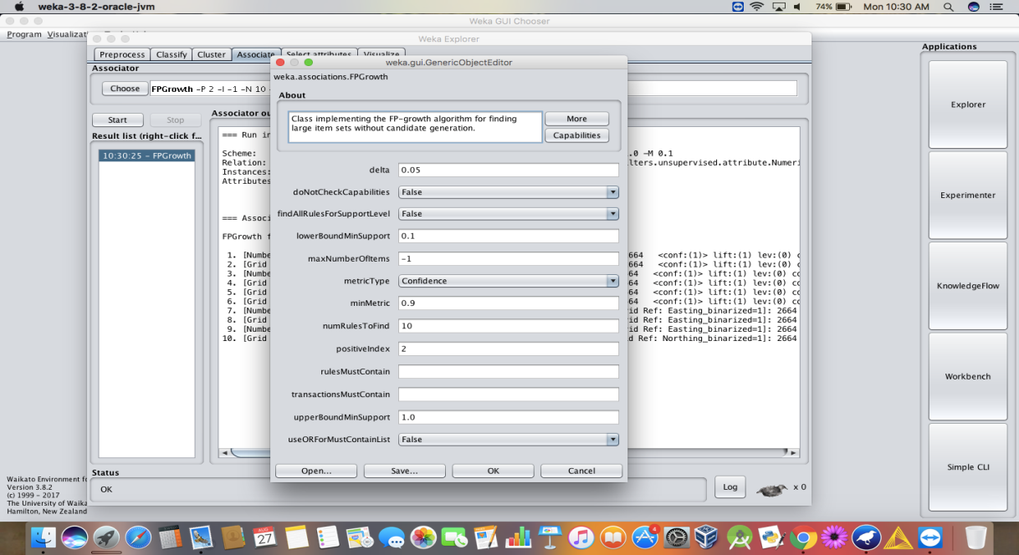

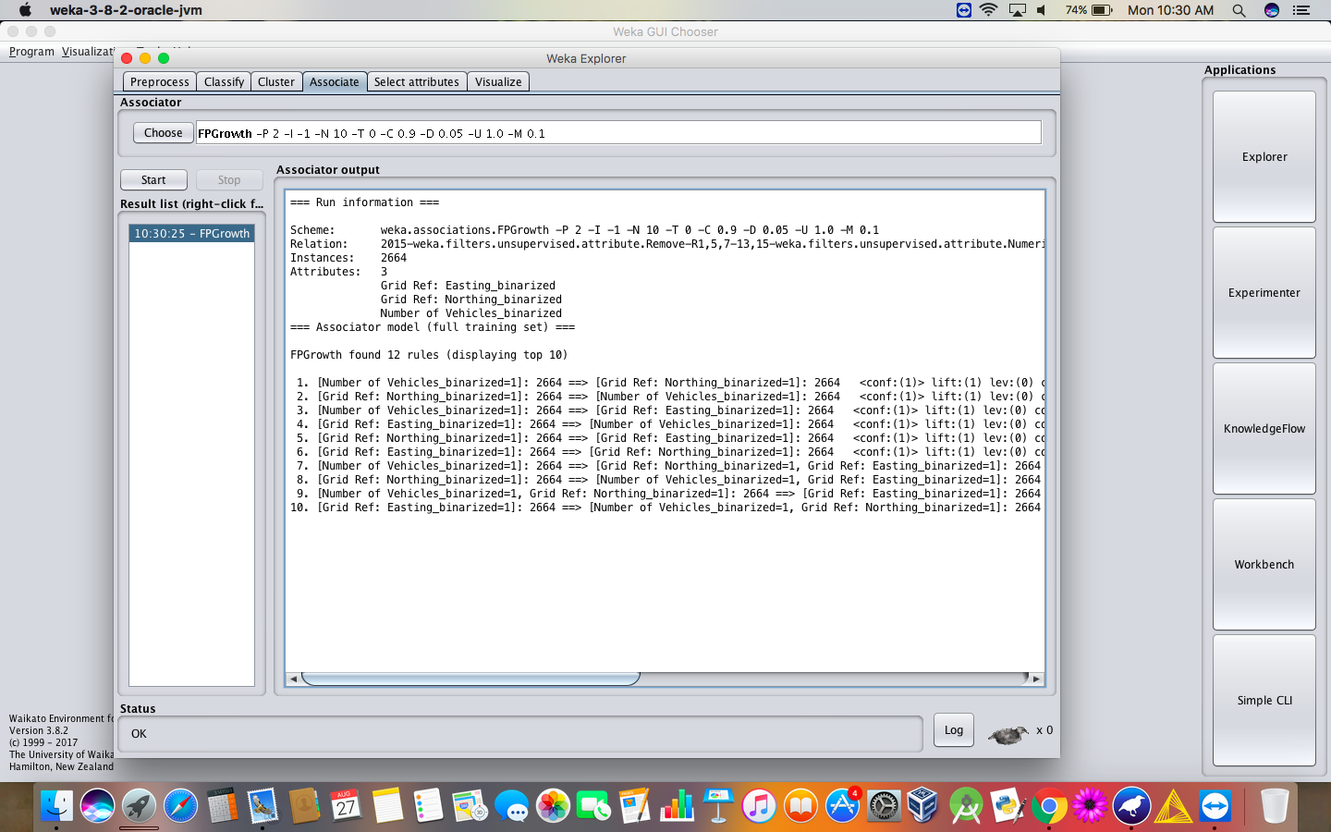

1. When the association rules are of values:
2. Upper bound min_sup = 2.0
3. Lower bound min_sup = 1.0
4. Metric type = confidence.

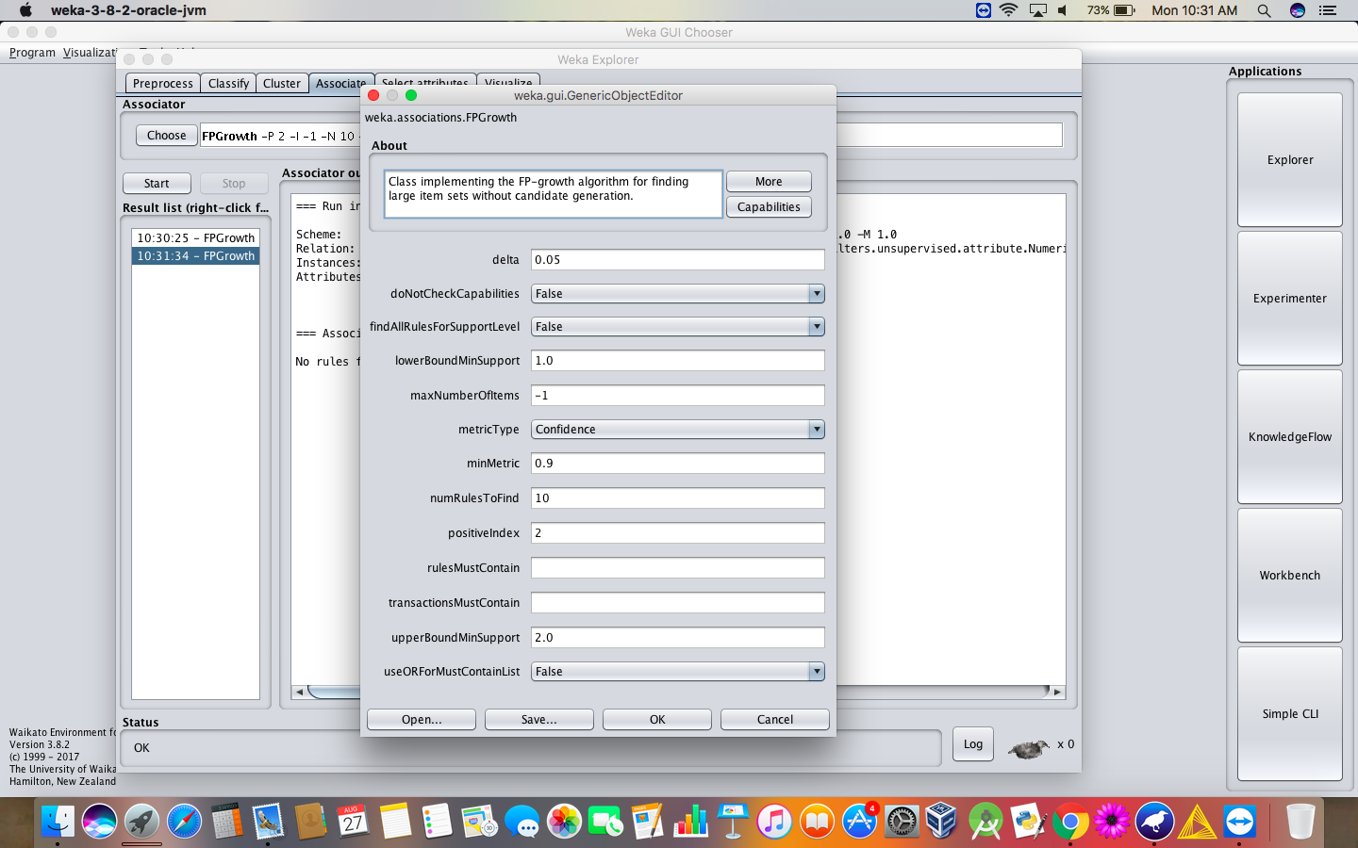

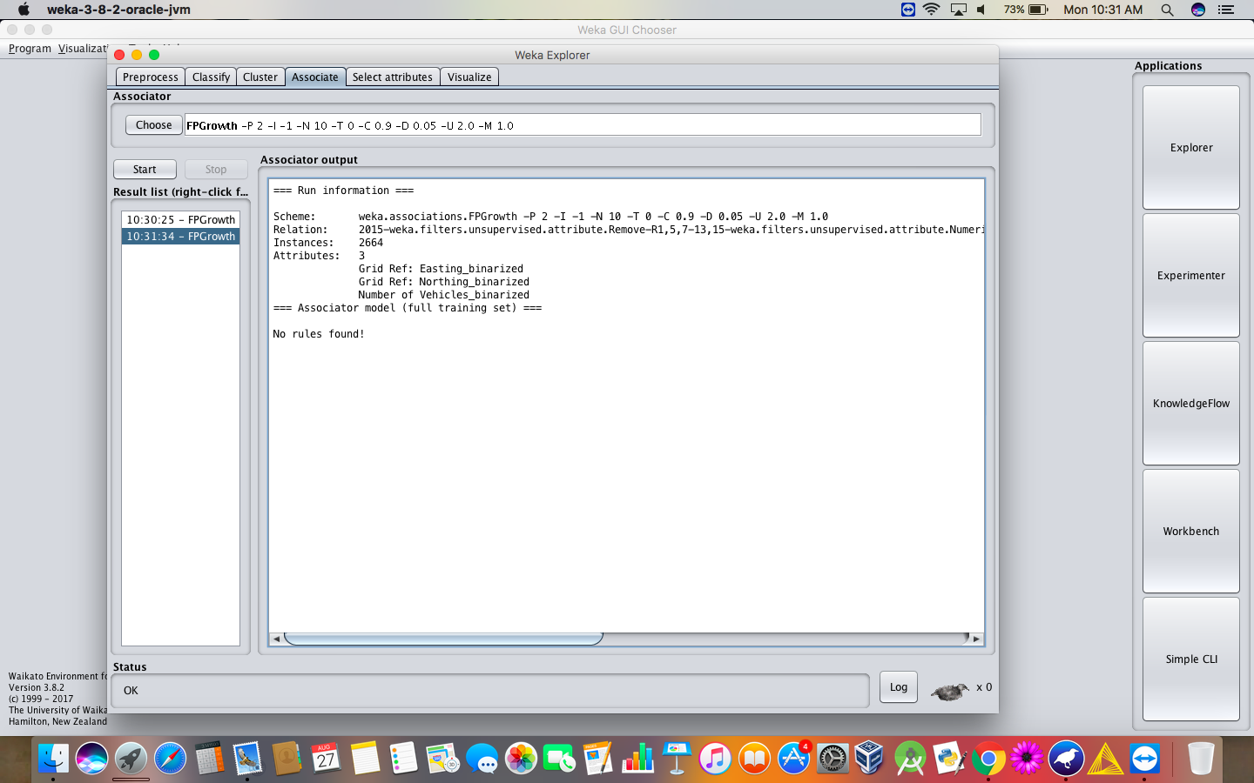

**RESULT :**

Thus, the analysis of FP growth algorithm using weka tool has been successfully completed. Incase of changing the upper bound and lower bound values there is a change in the number of rules that are found.